**ASSIGNMENT 6 java lab**

Arjun Tyagi

21070126020

AIML A1

**CODE-**

1)Fixed_STK

package pkg_Stack;  
  
public class Fixed_STK implements Interface_STK {  
 int fix_STK[]=new int[*MAX*];  
 int top=0;  
 @Override  
 public void push(int a) {  
 if(top==*MAX*)  
 System.*out*.println("Stack is Full can't insert");  
 else  
 fix_STK[top++]=a;  
  
 }  
  
 @Override  
 public int pop() {  
 if (top == 0)  
 return 0;  
 else {  
 return fix_STK[--top];  
 // top--;  
 }  
  
 }  
 @Override  
 public void displayStkTop() {  
 System.*out*.println("Stack top"+top);  
 System.*out*.println("Stack top Element"+fix_STK[top-1]);  
 }  
  
 @Override  
 public void displayStk() {  
 System.*out*.println("Stack elements");  
 for(int i=0;i<top;i++)  
 System.*out*.print(fix_STK[i]+" ");  
 System.*out*.println("\n");  
 }  
  
}

2)Interface_STK

package pkg_Stack;  
  
  
public interface Interface_STK {  
 int *MAX*=5;  
 void push(int a);  
 int pop();  
 void displayStkTop();  
 void displayStk();  
}

3)Main

package pkg_Stack;  
  
public class Main {  
 public static void main(String[] args) {  
 Fixed_STK f= new Fixed_STK();  
 f.push(9);  
 f.push(10);  
 f.push(11);  
 f.push(12);  
 f.push(13);  
 //f.push(14);  
 f.displayStkTop();  
 f.displayStk();  
 System.*out*.println(f.pop());  
 System.*out*.println(f.pop());  
 System.*out*.println(f.pop());  
 System.*out*.println(f.pop());  
 System.*out*.println(f.pop());  
 // System.out.println(f.pop());  
 }  
}

Output-

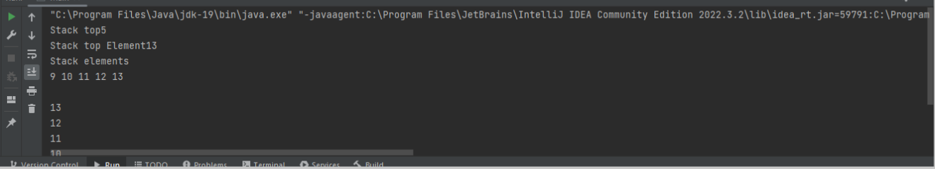

Github link- <https://github.com/arjuntyagi19/java_assignment>